Name – Priyanshu Tyagi

Roll no – 1901610100149

Implementation of traversing

#include <stdio.h>

int main(void) {
int n;
printf(“TRAVERSAL OF ARRAY\n”);
printf("Enter size of array\n");
scanf("%d",&n);
int i, a[n];
printf("Enter elements\n");
for(i=0; i<n; i++)
{
scanf("%d",&a[i]);
}
printf("Elements:\n");
for(i=0; i<n; i++)
{
printf("%d ",a[i]);
}
return 0;
}

OUTPUT:
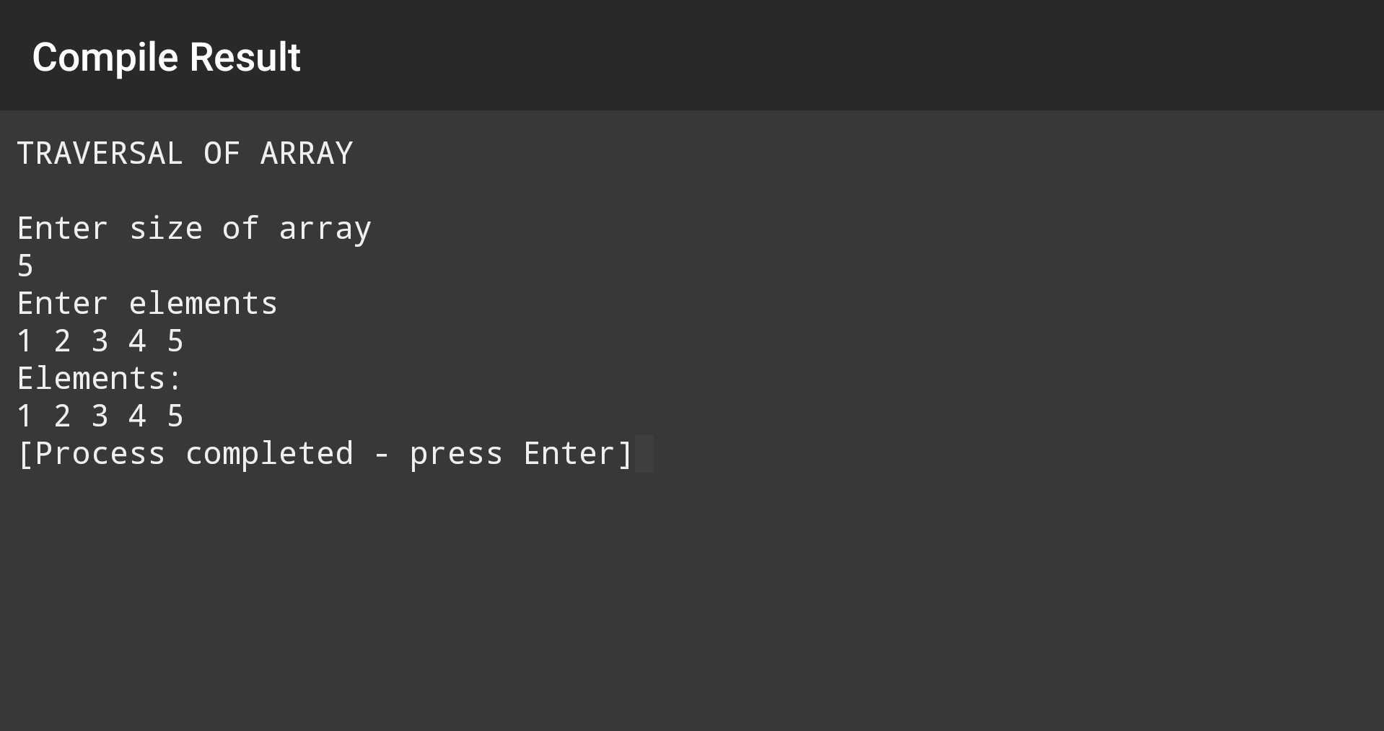

Implementation of Linear Search
#include <stdio.h>

int main()
{
int n, search;
printf("LINEAR SEARCH\n");
printf("Enter number of elements\n");
scanf("%d", &n);
int i, array[n];
printf("Enter %d integer(s)\n", n);

for (i = 0; i < n; i++)
scanf("%d", &array[i]);

printf("Enter value to find\n");
scanf("%d", &search);

for (i = 0; i < n; i++)
{
if (array[i] == search)
{
printf("%dfound at location %d.\n", search, i+1);
break;
}
}
if (i == n)
printf("%d isn't present in the array.\n", search);

return 0;
}

OUTPUT:
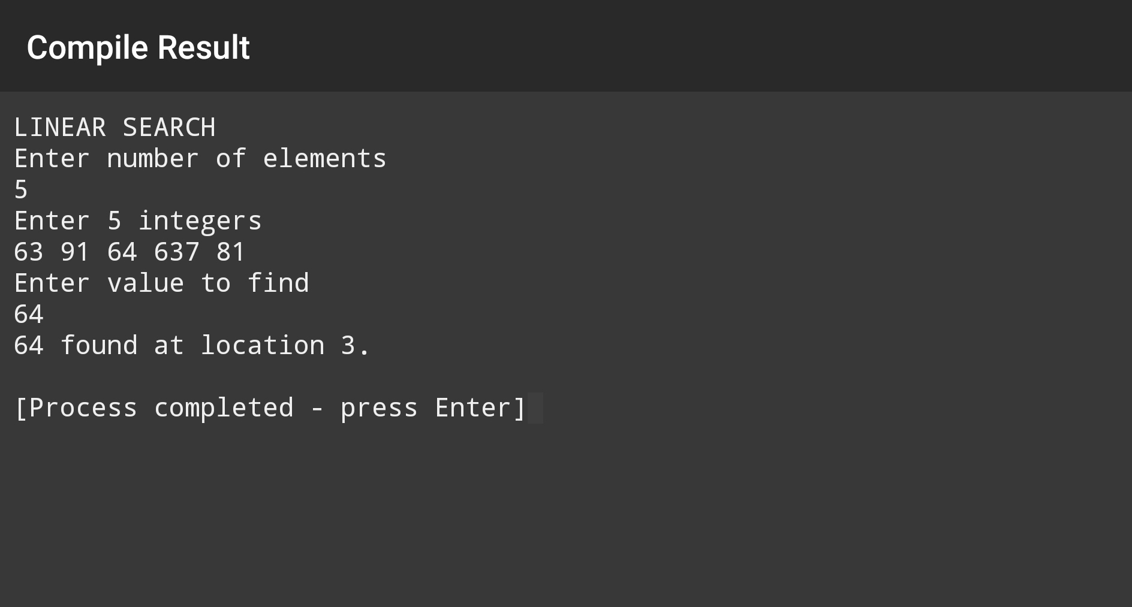
Implementation of Binary Search
#include <stdio.h>

int main()
{
int first, last, middle, n, search;

printf("Enter number of elements\n");
scanf("%d", &n);
int array[n],i;
printf("Enter elements\n");

for (i = 0; i < n; i++)
scanf("%d", &array[i]);

printf("Enter value to find\n");
scanf("%d", &search);

first = 0;
last = n - 1;
middle = (first+last)/2;

while (first <= last) {
if (array[middle] < search)
first = middle + 1;
else if (array[middle] == search) {
printf("%d found at location %d.\n", search, middle+1);
break;
}
else
last = middle - 1;

middle = (first + last)/2;
}
if (first > last)
printf("Not found! %d isn't present in the list.\n", search);

return 0;
}

OUTPUT:
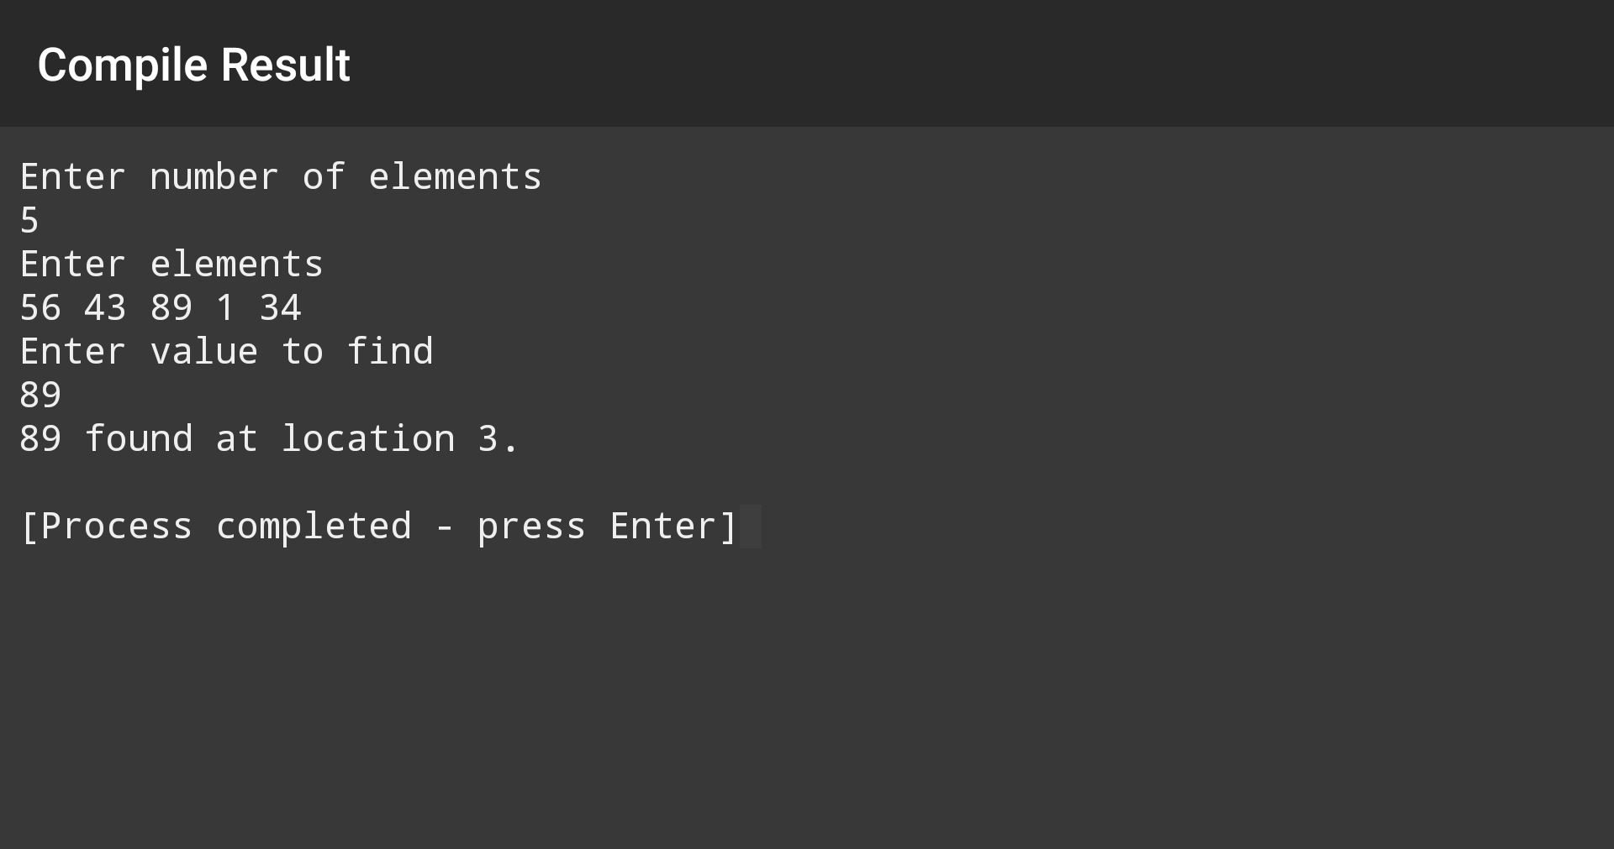
Implementation of Selection Sort
#include <stdio.h>

int main()
{
int n, i, j, position, t;
printf("SELECTION SORT\n");
printf("Enter number of elements\n");
scanf("%d", &n);
int array[n];
printf("Enter %d integers\n", n);

for (i = 0; i < n; i++)
scanf("%d", &array[i]);

for (i = 0; i < (n - 1); i++) // finding minimum element (n-1) times
{
position = i;

for (j = i + 1; j < n; j++)
{
if (array[position] > array[j])
position = j;
}
if (position != i)
{
t = array[i];
array[i] = array[position];
array[position] = t;
}
}

printf("Sorted list in ascending order:\n");

for (i = 0; i < n; i++)
printf("%d\n", array[i]);

return 0;
}

OUTPUT:
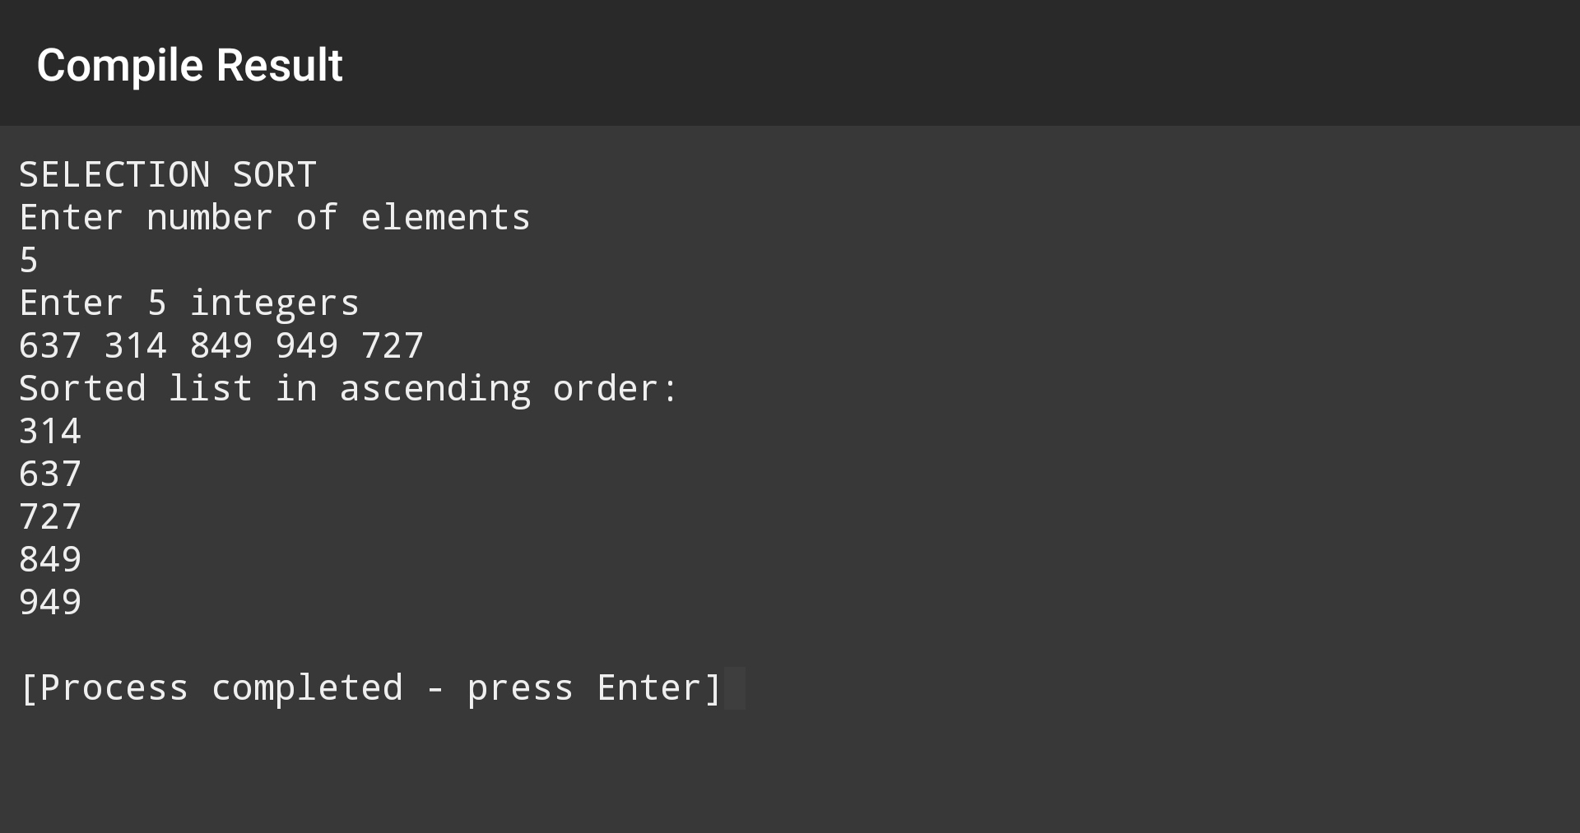
Implementation of Insertion Sort
#include <stdio.h>

int main()
{
int n, i, j, t, flag = 0;
printf("INSERTION SORT\n");
printf("Enter number of elements\n");
scanf("%d", &n);
int array[n];
printf("Enter %d integers\n", n);

for (i = 0; i < n; i++)
scanf("%d", &array[i]);

for (i = 1 ; i <= n - 1; i++) {
t = array[i];

for (j = i - 1 ; j >= 0; j--) {
if (array[j] > t) {
array[j+1] = array[j];
flag = 1;
}
else
break;
}
if (flag)
array[j+1] = t;
}

printf("Sorted list in ascending order:\n");

for (i = 0; i <= n - 1; i++) {
printf("%d\n", array[i]);
}

return 0;
}

OUTPUT:
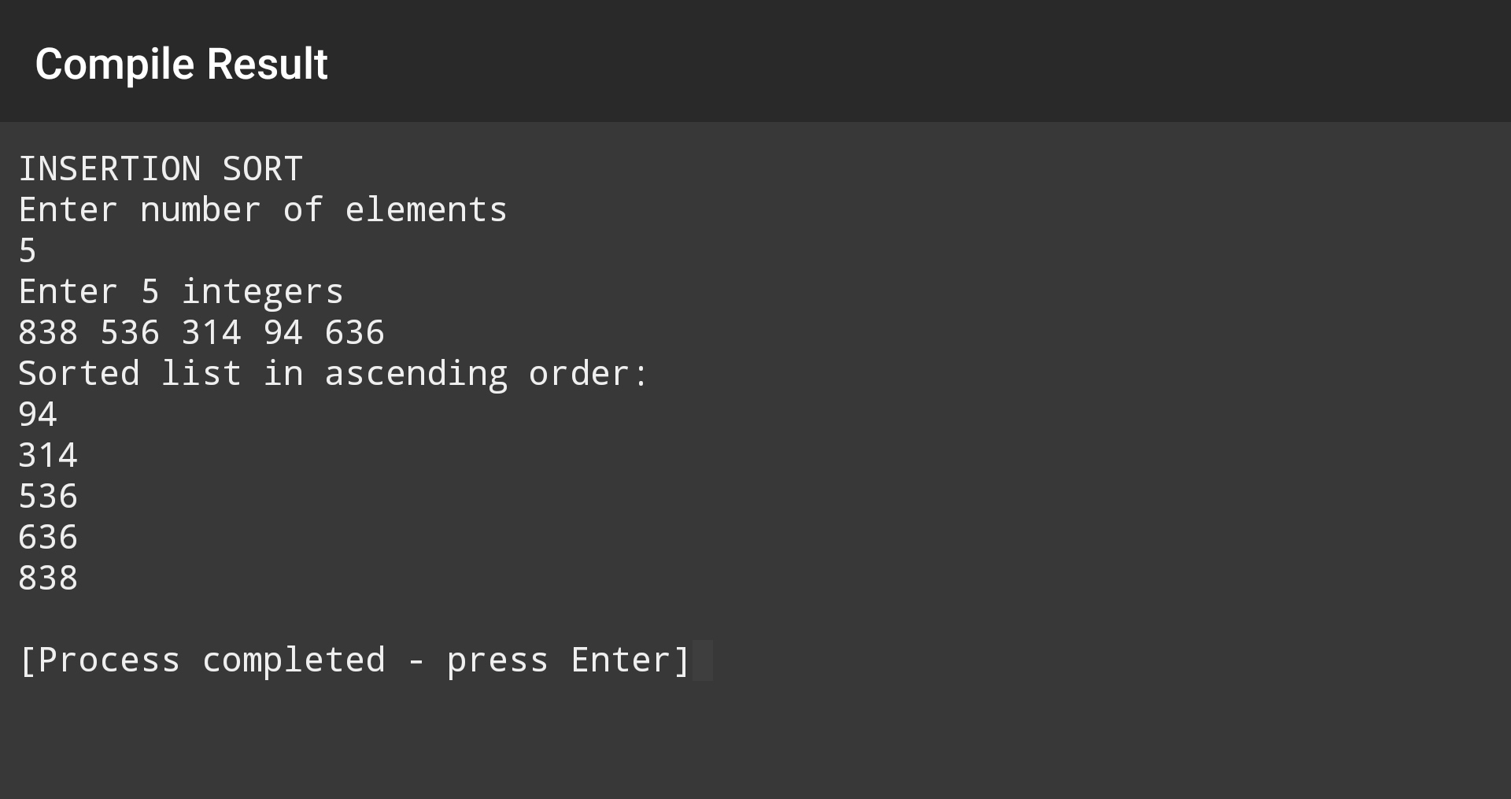
Implementation of Bubble Sort
#include <stdio.h>

int main()
{
int n, i, j, swap;
printf("BUBBLE SORT\n");
printf("Enter number of elements\n");
scanf("%d", &n);
int array[n];
printf("Enter %d integers\n", n);

for (i = 0; i < n; i++)
scanf("%d", &array[i]);

for (i = 0 ; i < n - 1; i++)
{
for (j = 0 ; j < n - i - 1; j++)
{
if (array[j] > array[j+1])
{
swap = array[j];
array[j] = array[j+1];
array[j+1] = swap;
}
}
}

printf("Sorted list in ascending order:\n");

for (i = 0; i < n; i++)
printf("%d\n", array[i]);

return 0;
}

OUTPUT:
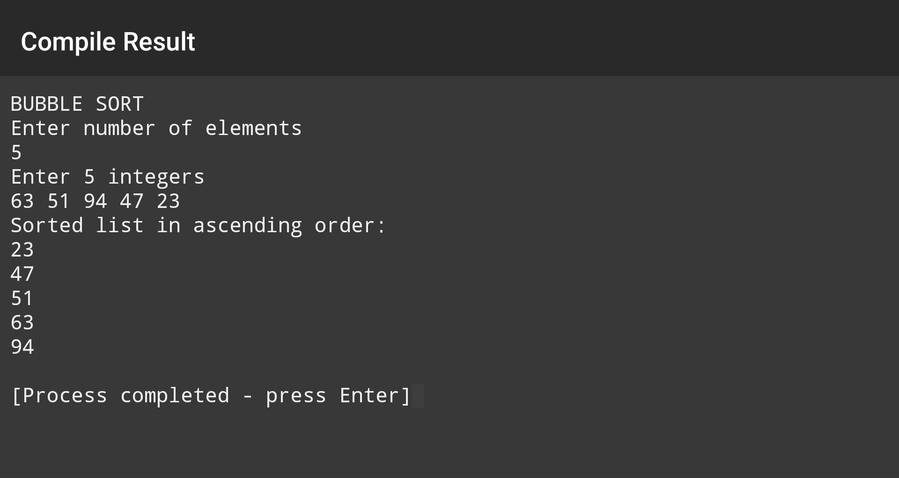
Implementation of Quick Sort
#include<stdio.h>

void swap(int* a, int* b)
{
int t = *a;
*a = *b;
*b = t;
}

int partition (int arr[], int low, int high)
{
int pivot = arr[high];
int i = (low - 1);

for (int j = low; j <= high- 1; j++)
{
if (arr[j] < pivot)
{
i++;
swap(&arr[i], &arr[j]);
}
}
swap(&arr[i + 1], &arr[high]);
return (i + 1);
}

void quickSort(int arr[], int low, int high)
{
if (low < high)
{
int pi = partition(arr, low, high);
quickSort(arr, low, pi - 1);
quickSort(arr, pi + 1, high);
}
}

void printArray(int arr[], int size)
{
int i;
for (i=0; i < size; i++)
printf("%d\n", arr[i]);
}

int main()
{
int n, i;
printf("QUICK SORT\n");
printf("Enter number of elements\n");
scanf("%d", &n);
int arr[n];
printf("Enter %d integers\n", n);
for (i = 0; i < n; i++){
scanf("%d", &arr[i]);
}
quickSort(arr, 0, n-1);
printf("Sorted list in ascending order: \n");
printArray(arr, n);
return 0;
}

OUTPUT:
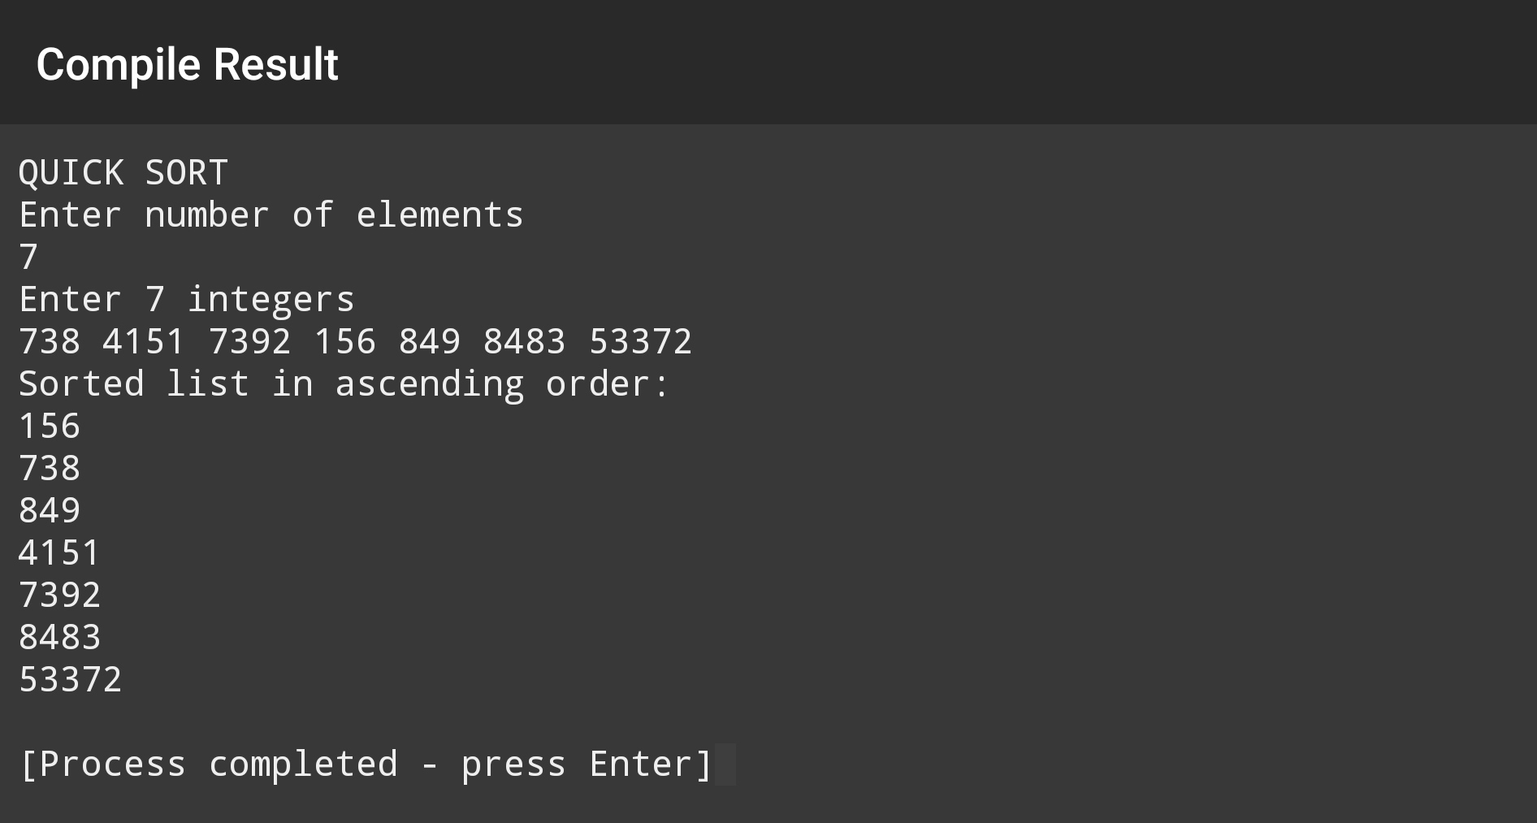
Implementation of Merge Sort
#include <stdio.h>
#include <stdlib.h>

void merge(int arr[], int l, int m, int r)
{
int i, j, k;
int n1 = m - l + 1;
int n2 = r - m;

int L[n1], R[n2];

for (i = 0; i < n1; i++)
L[i] = arr[l + i];
for (j = 0; j < n2; j++)
R[j] = arr[m + 1 +j];

i = 0;
j = 0;
k = l;
while (i < n1 && j < n2) {
if (L[i] <= R[j]) {
arr[k] = L[i];
i++;
}
else {
arr[k] = R[j];
j++;
}
k++;
}

while (i < n1) {
arr[k] = L[i];
i++;
k++;
}

while (j < n2) {
arr[k] = R[j];
j++;
k++;
}
}
void mergeSort(int arr[], int l, int r)
{
if (l < r) {
int m = l + (r - l) / 2;

mergeSort(arr, l, m);
mergeSort(arr, m + 1, r);

merge(arr, l, m, r);
}
}

void printArray(int A[], int size)
{
int i;
for (i = 0; i < size; i++)
printf("%d\n", A[i]);
}

int main()
{
int arr_size, i;
printf("MERGE SORT\n");
printf("Enter number of elements\n");
scanf("%d",&arr_size);
int arr[arr_size];
printf("Enter %d integers\n", arr_size);
for(i=0; i<arr_size; i++)
{
scanf("%d",&arr[i]);
}
mergeSort(arr, 0, arr_size - 1);
printf("Sorted list in ascending order:\n");
printArray(arr, arr_size);
return 0;
}

OUTPUT:
